**A REPORT**

**ON**

**‘Library for Machine Learning Classifications’**

**BY**

|  |  |
| --- | --- |
| Name of the Student | ID Number |
| ***Akash Reddy D*** | ***2016A7PS0069G*** |

Prepared on completion of the project for

Course No. BITS F464

**AT**

**BIRLA INSTITUTE OF TECHNOLOGY AND SCIENCES GOA**



# **BAYESIAN CLASSIFIER**

For the dataset “IRIS” the accuracy scored was 0.96 using accuracy_score metric in sklearn module.

The output for the module imported from sklearn gave slightly different results compared to the model made by us. Test data was made after splitting the IRIS dataset using train_test_split.

The accuracy came out to be 0.96 for module made using accuracy_score metric from sklearn.

Both the Gaussian and Multinomial naive bayes have been implemented.

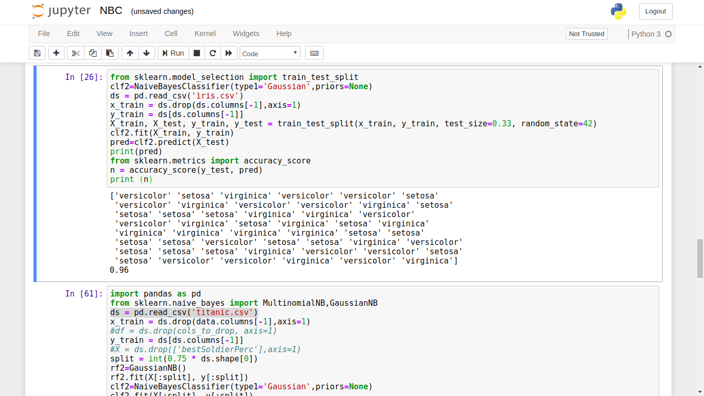

# 

# 

# 

# **DECISION TREE CLASSIFIER**

The decision tree classifier gave an accuracy of 0.973 accuracy for IRIS dataset and for TITANIC dataset gave an accuracy of 0.7584 after testing the data we got after splitting each of them with 0.33 as test_size.

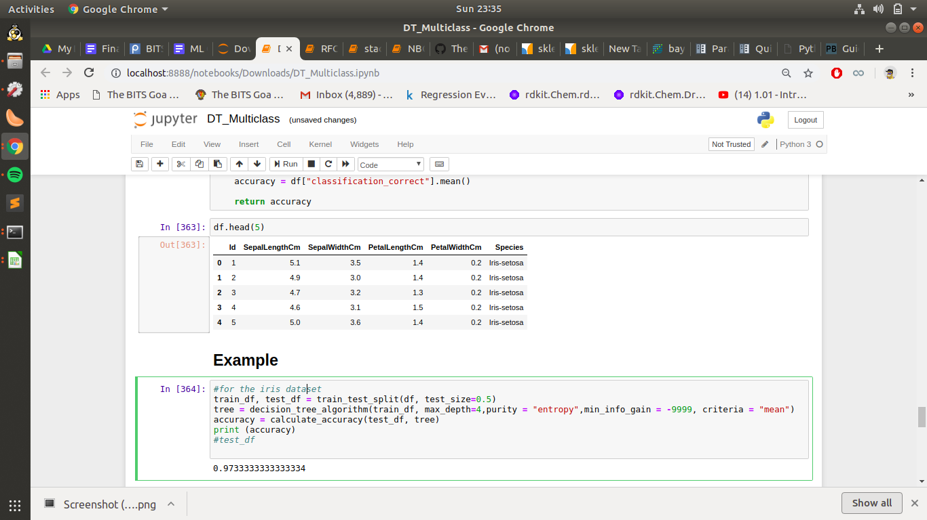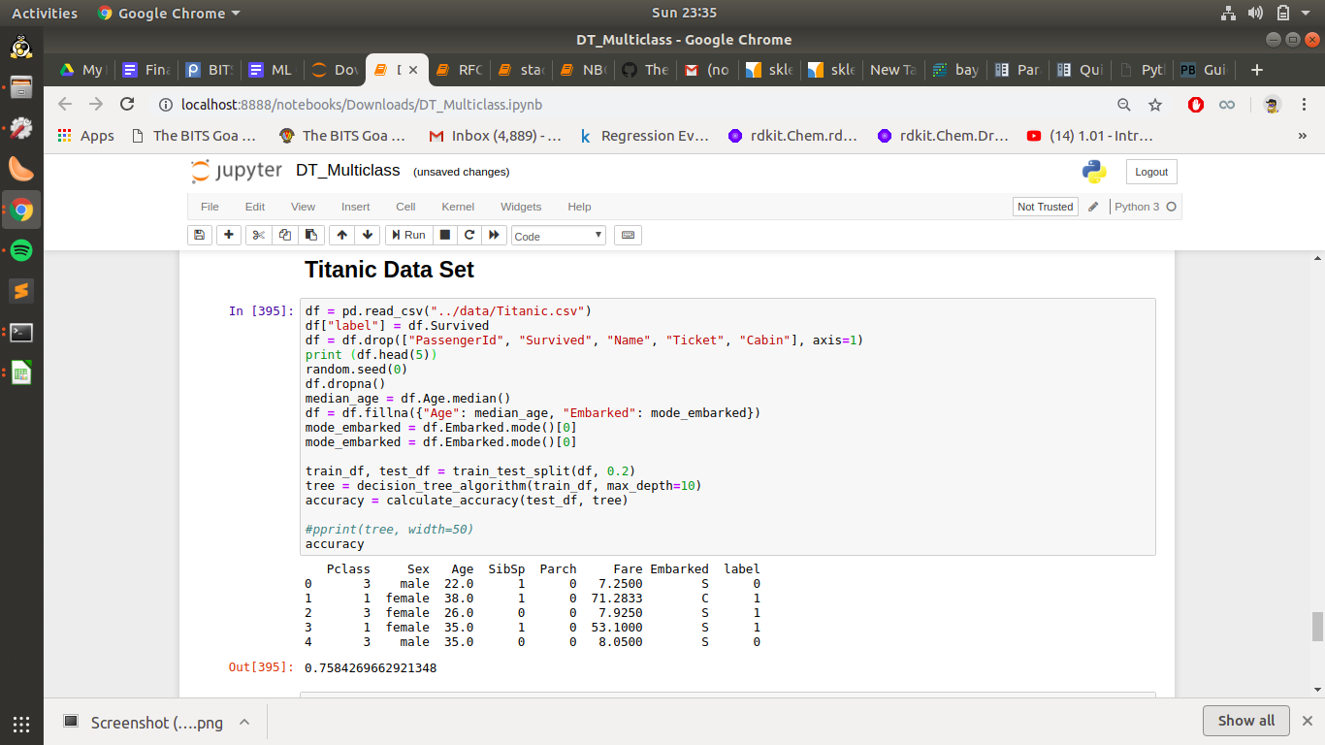

# **RANDOM FOREST CLASSIFIER**

The Random Forest Classifier gave out 0.98 accuracy on using accuracy_score metric on “IRIS” dataset after splitting the dataset using train_test_split.

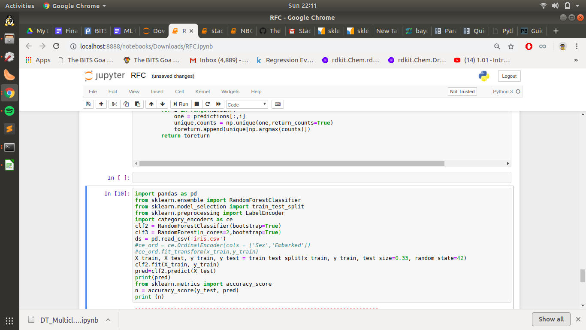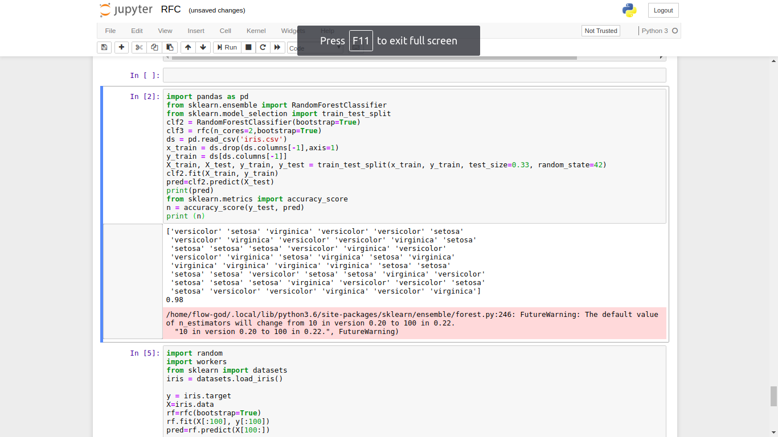

# 

# **STACKING**

For the Stacking written we had results which gave an accuracy of 0.92 after making a split of 33 percent using train_test_split.

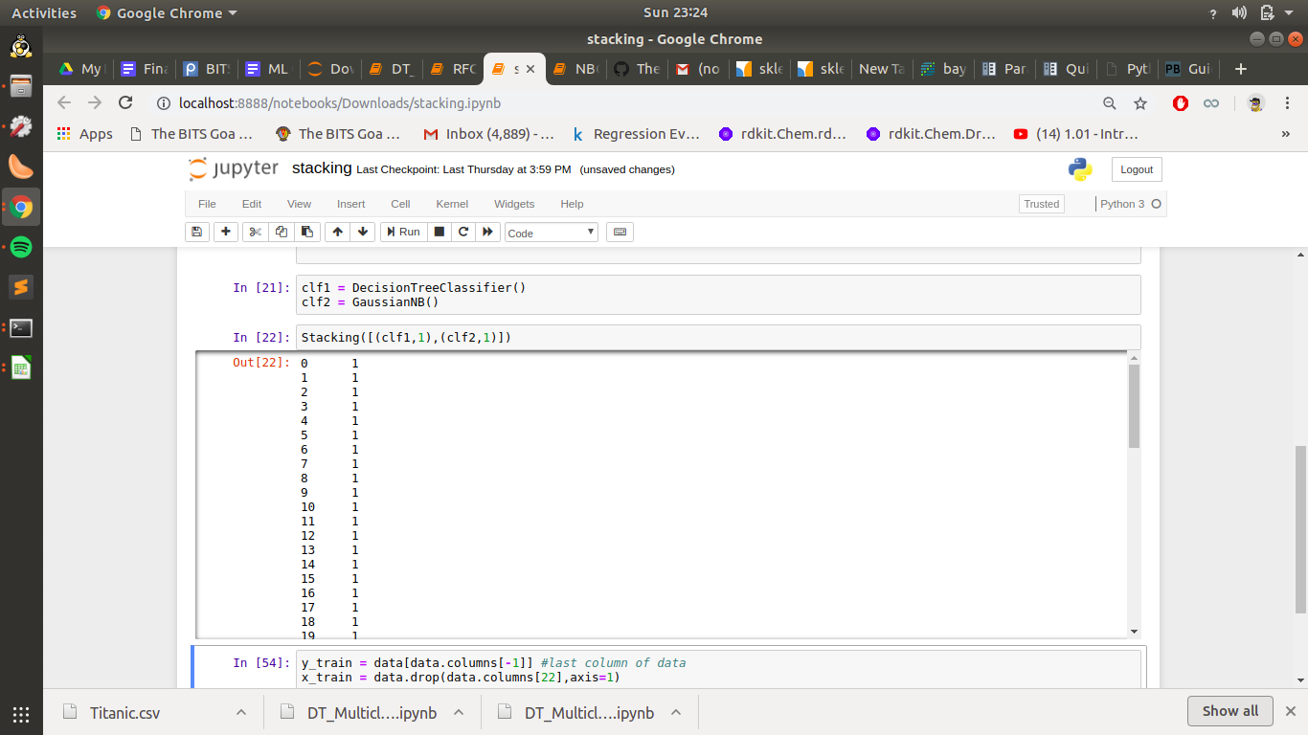

# 

# 

# **LOGISTIC REGRESSION CLASSIFIER**

# 

For the Logistic Regression Model accuracy of 0.66 was obtained after testing it on the IRIS dataset using

train_test_split of sklearn for testing purpose.

